Gian Russell D. Villegas BSIT 3-C IT Elec 1 – Web Development

Documentation: Robiel Prince Café Website using “Populating from a Database”

This Lab activity is a Laravel-based web application for a Family café business named RobielPrince Café proposed by my mother and father. So, I thought of making a website for it in the idea that someday it will help out the business. It features a homepage, a menu page, and a login system. The web application dynamically fetches and displays data from a database.

1. Screenshots of Rendered Pages

Homepage (homepage.blade.php)  
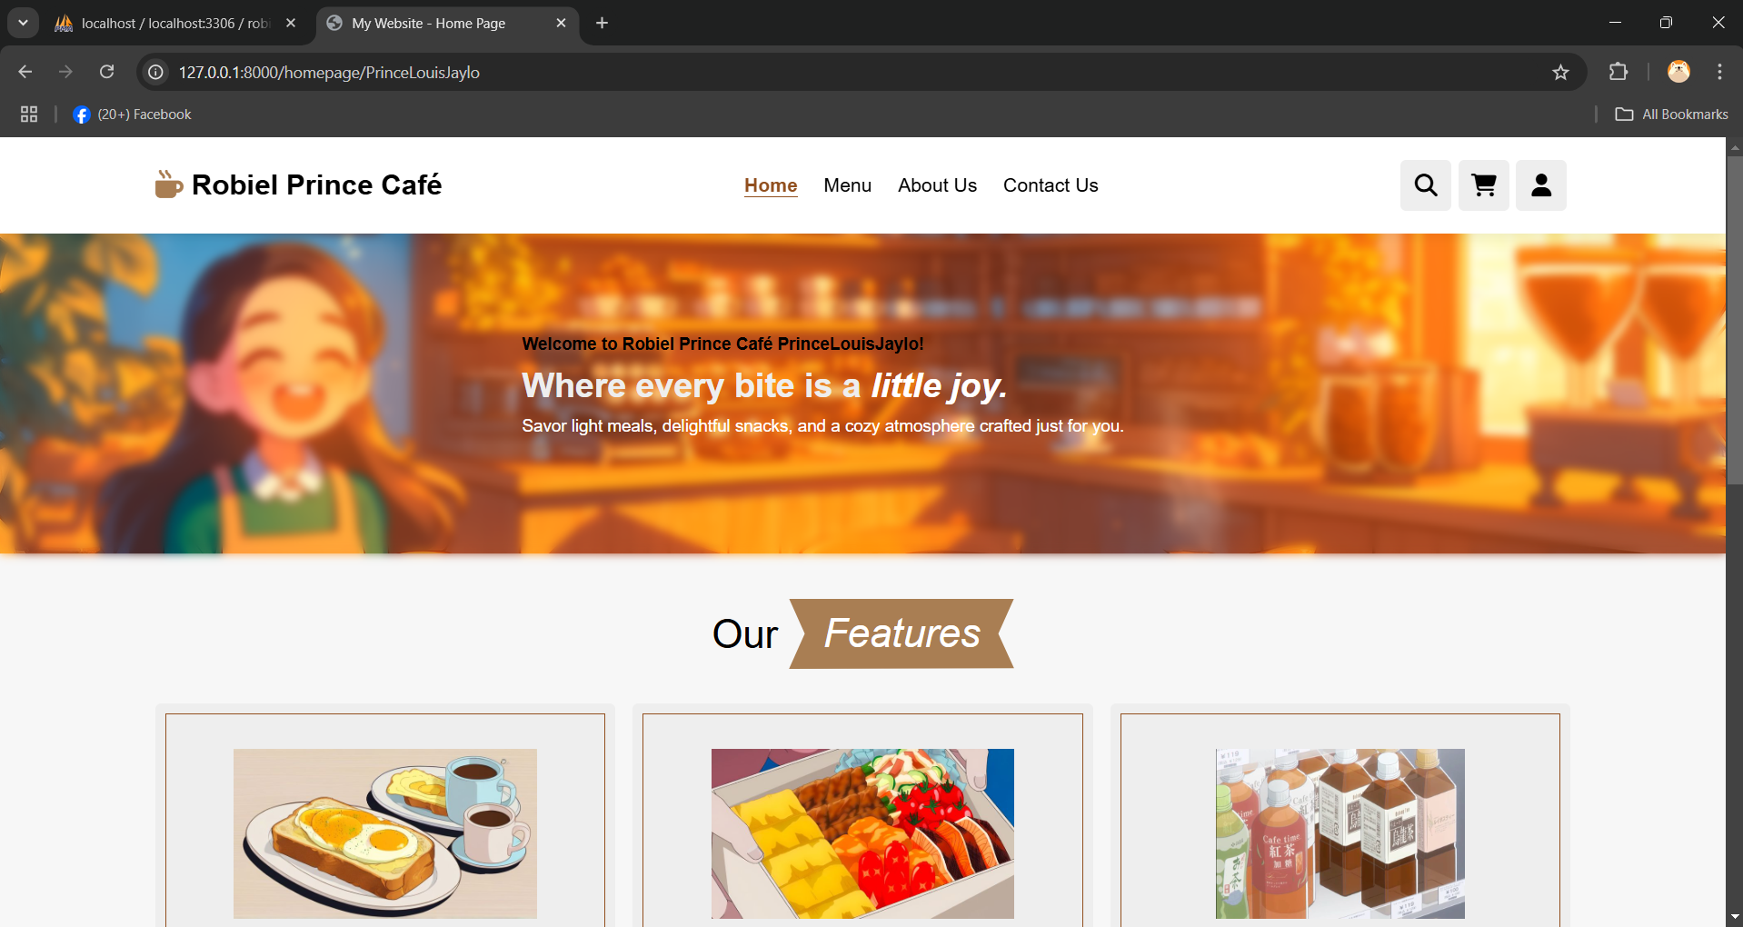

The homepage greets the user with a welcome message, shows the café's features (e.g., breakfast, lunch, drinks), and lists "Best Sellers" with images, prices, and ratings.

The welcome message with the user's name (Welcome to Robiel Prince Café Guest! or the users name e.g., PrinceLouisJaylo). The features section with images and descriptions (e.g., "Morning Delights"). The Best Sellers section with product names, prices, and ratings.

Menu Page (menu.blade.php)  
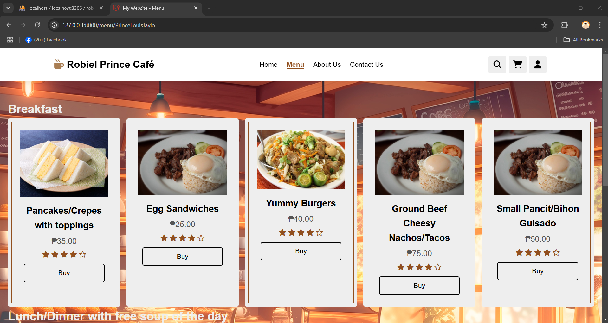  
The menu page displays a list of food items dynamically fetched from the database. Each item includes a name, price, image, and rating.

Login Page (goTologin.blade.php)  
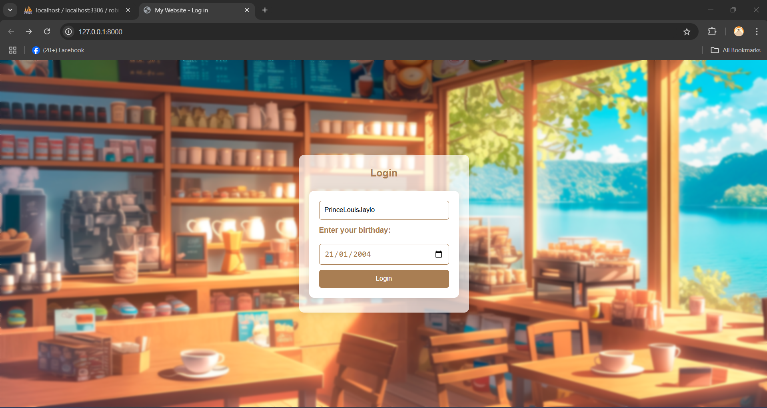  
The login page includes a form where the user can input their name and birthday to log in. Validation errors are displayed if invalid data is submitted. We can see in the login form with fields for name and birthday. A submission button "Login”. Optionally, a of the message when invalid data is entered for example "Please fill out this field" or “Please match the requested format”.

2. Explanations for Each Page  
HomePageController.php  
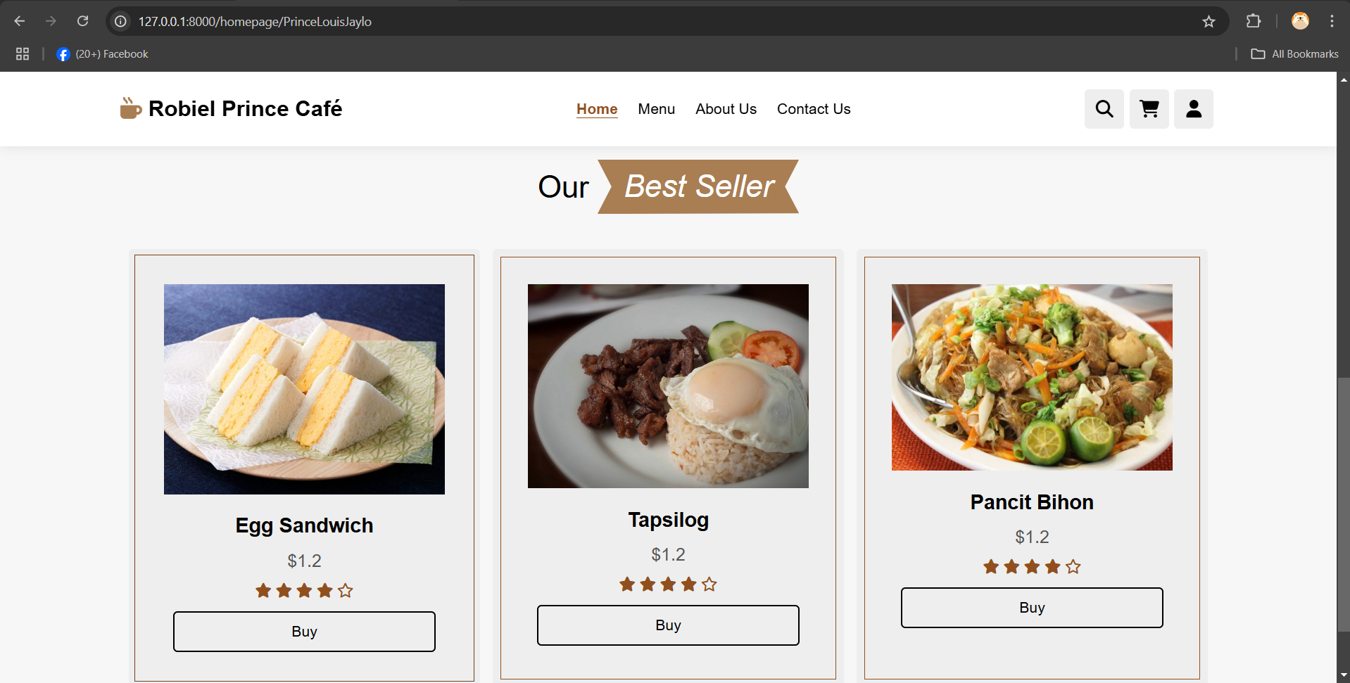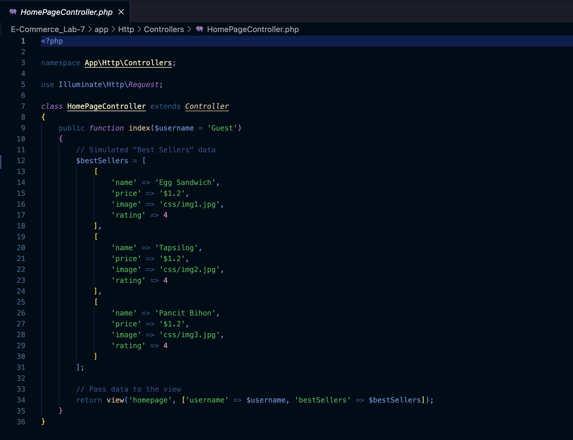  
  
The HomePageController handles the homepage logic. It simulates "best sellers" data and passes it to the view. The $username parameter defaults to 'Guest' if no username is provided. The $username parameter is retrieved from the route and passed to the view. It allows the page to personalize greetings dynamically.

MenuController.php  
  
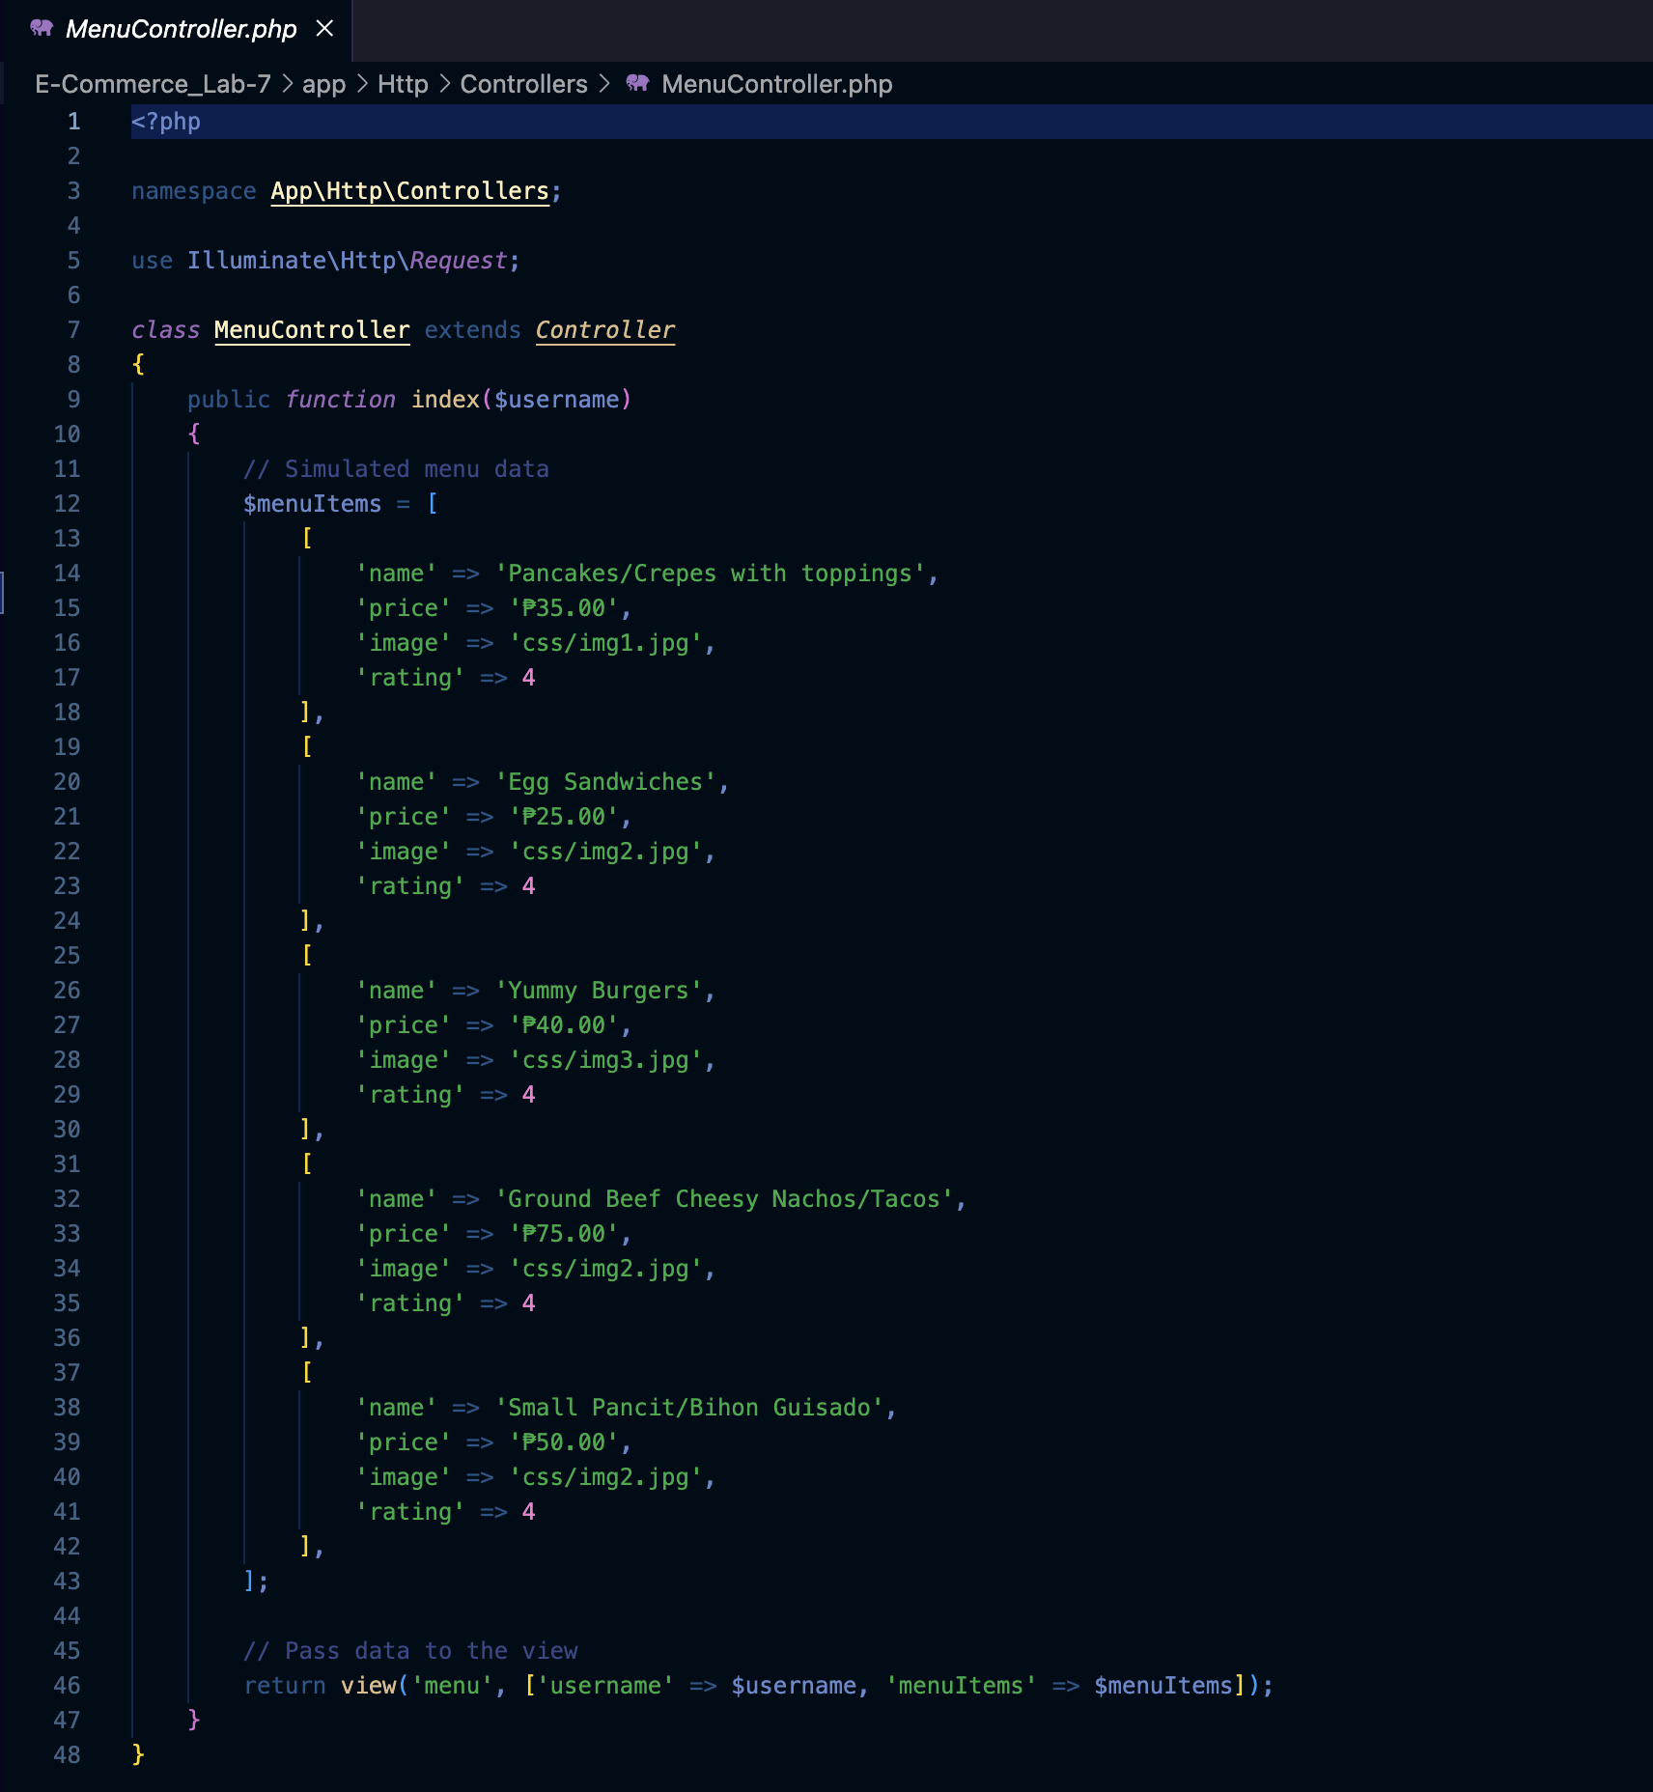  
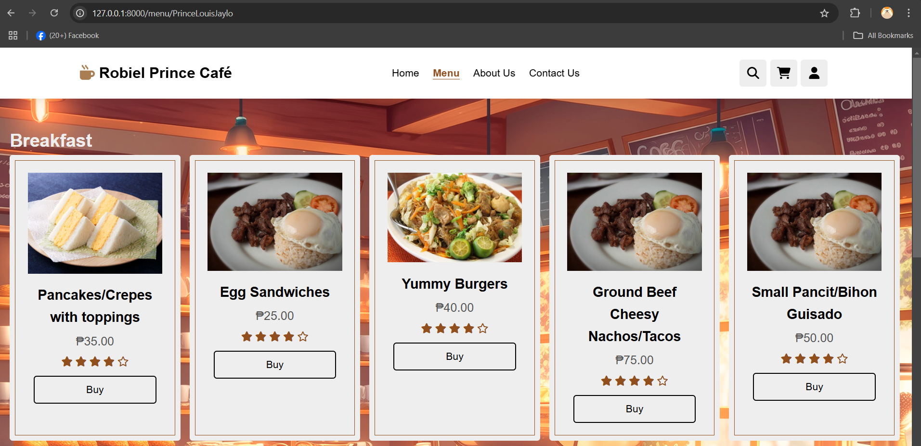  
The MenuController fetches the menu items from the menu_items database table using the MenuItem model and passes the data to the view. The $username parameter is retrieved from the route and used to personalize the menu page.

LoginController.php  
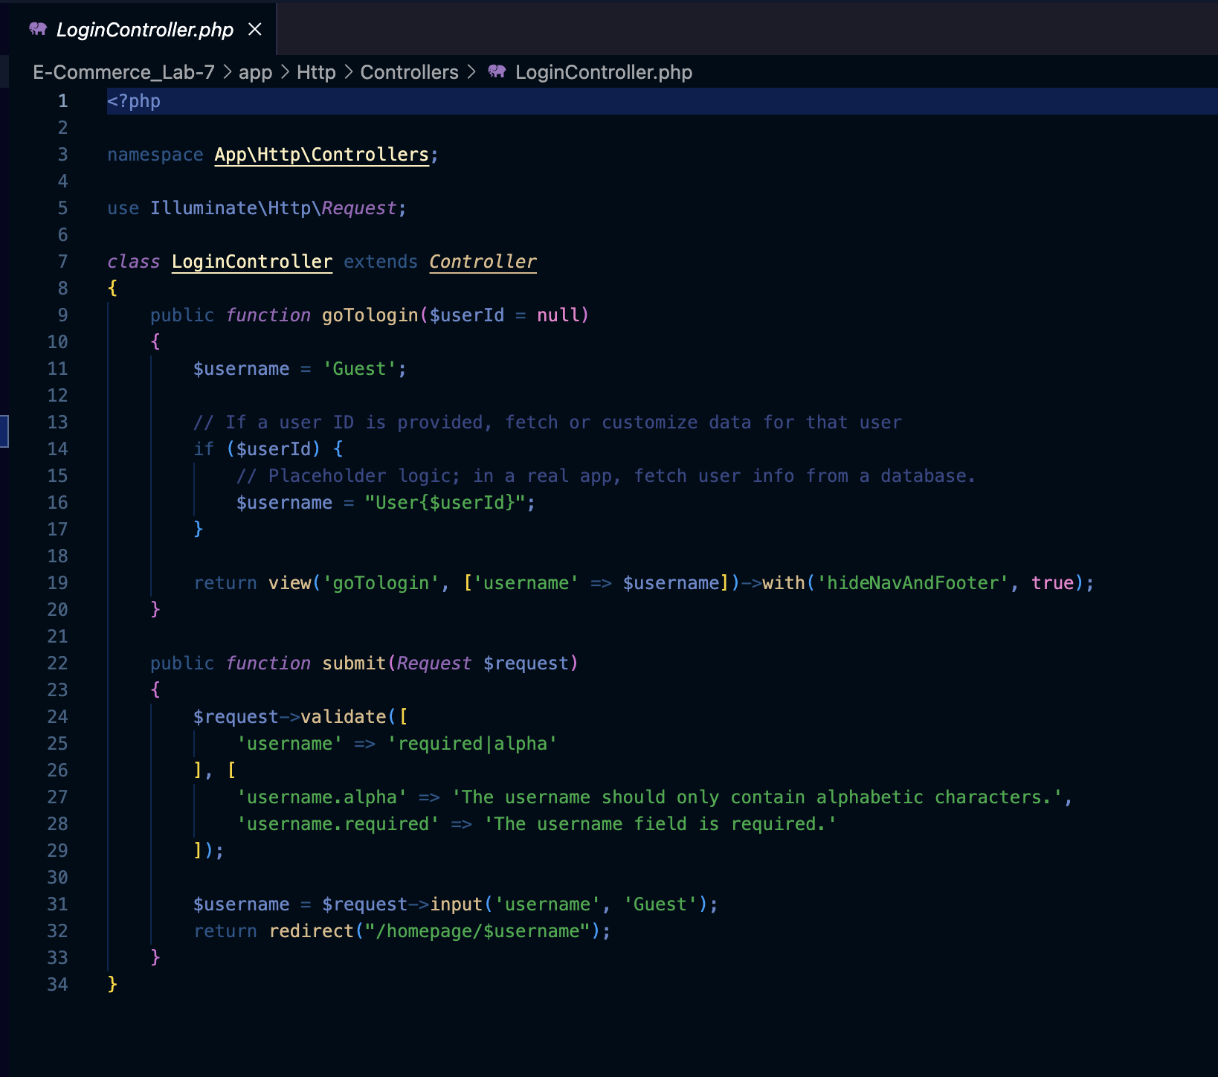  
  
The LoginController displays the login form. Upon submission, it validates the username and redirects to the homepage with the provided username. The login form takes user input (username) and validates it. The username is passed as a route parameter to personalize the homepage.

.env file  
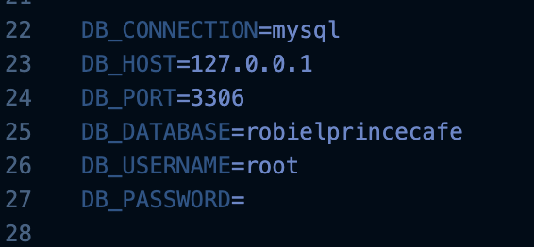  
This is where I connected the data base of the website using XAMPP

Models/MenuItem.php  
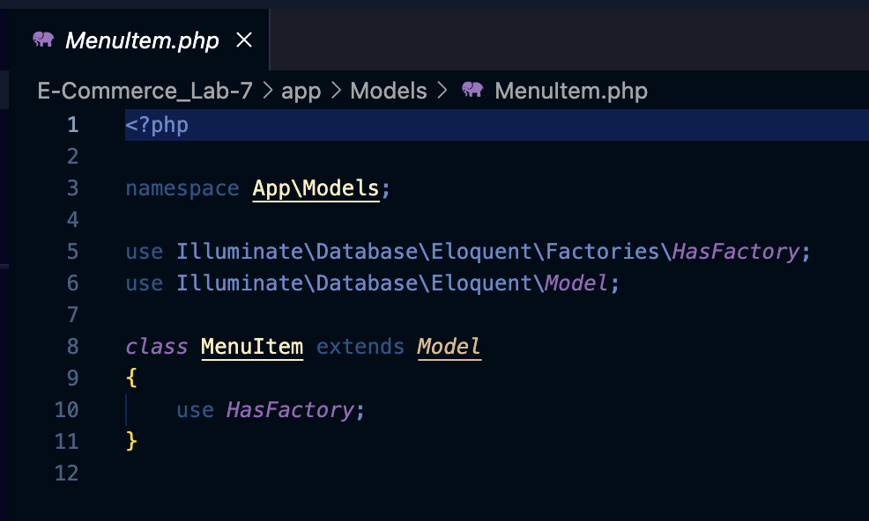  
This MenuItem file is a Laravel model. A model represents a table in the database and allows you to interact with it. For example: It will be used to fetch or save menu items (like dishes) from/to the database. When the MenuController needs menu data, it can use this model to get it easily. The HasFactory part helps create fake menu items for testing or adding sample data during development.

Migration Files  
Menu:  
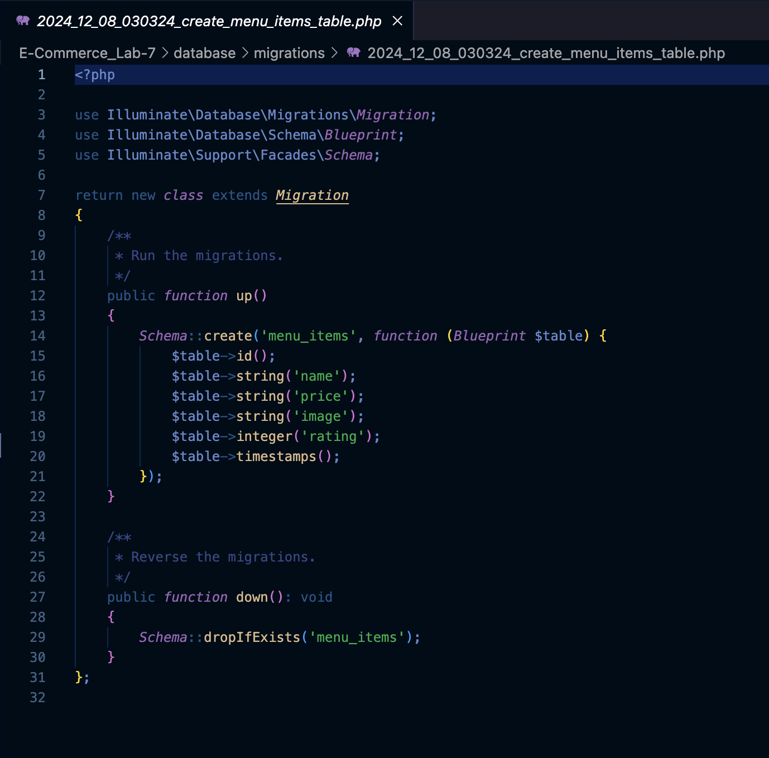  
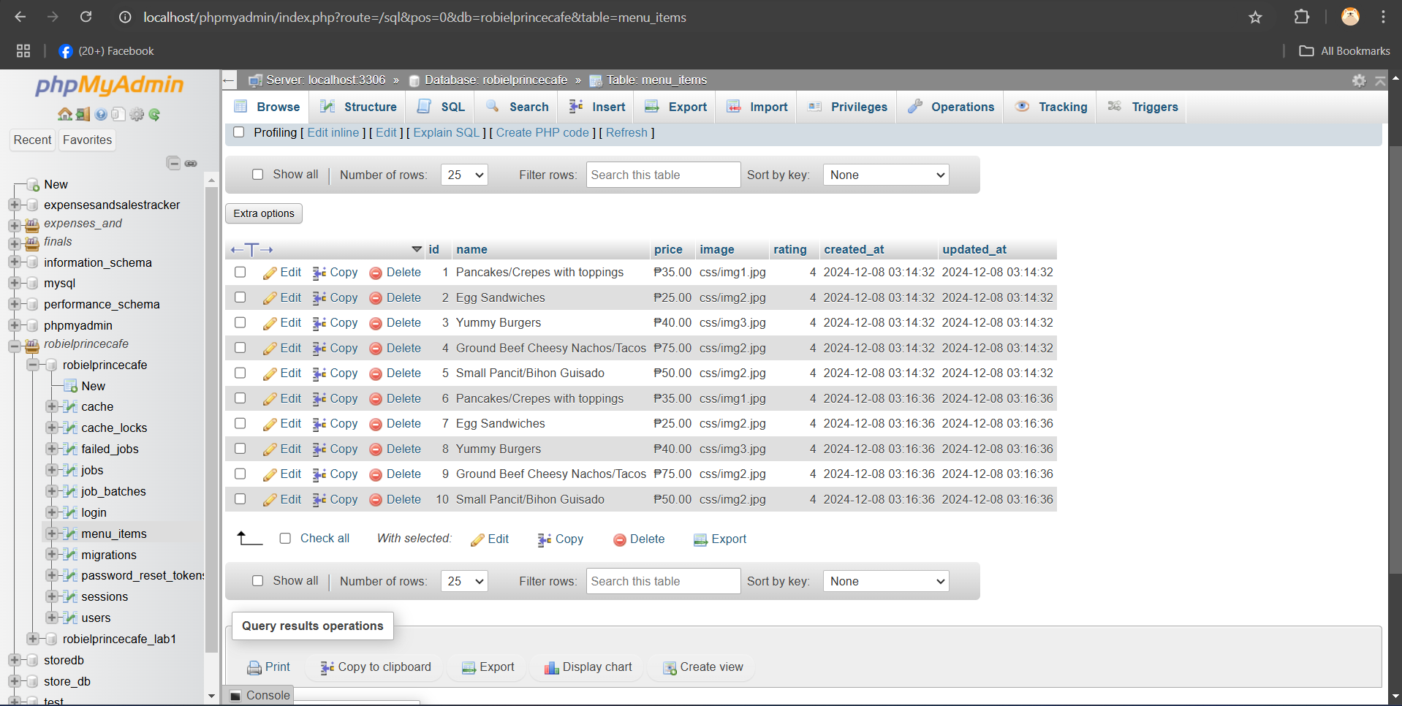  
This migration creates a menu_items table in the database with columns for the item's id, name, price, image, rating, and timestamps (created_at and updated_at). The up() method builds the table, while the down() method removes it if needed, ensuring the database structure aligns with the application requirements.